

**INTERNATIONAL SCHOOL**

**CAPSTONE PROJECT 1**

**CMU-CS 246 HIS**

**PROJECT PLAN DOCUMENT**

Version: 1.1

**CALCULATION SOFTWARE – CS**

**Mentor: Nguyen Dang Quang Huy**

***Team Member*:**

Lê Quang Anh

Trương Xuân Bảo

Phạm Quỳnh Chi

Bùi Tạ Hồng Đạt

Liễu Thị Thuỳ Trang

**Approved by Huy Nguyen Dang Quang**

**Project Plan Review Panel Representative:**

Name Signature Date

**Capstone Project 1- Mentor:**

Name Signature Date

Da Nang, 01/2024

**PROJECT INFORMATION**

| **Project Acronym** | CS |
| --- | --- |
| **Project Title** | Calculation Software | | | |
| **Start Date** | 25 – Jan –2024 | **End Date** | 19 – Fer –2024 | |
| **Lead Institution** | International School, Duy Tan University | | | |
| **Team Member** | **Name** | **Email** | | **Phone** |
| 28211100194 | Lê Quang Anh | lequanganhh1624@gmail.com | | 0329163990 |
| 28211133323 | Trương Xuân Bảo | [truongxuanbao2004@gmail.com](mailto:truongxuanbao2004@gmail.com) | | 0889606440 |
| 28209020840 | Phạm Quỳnh Chi | [quynhchihtk84@gmail.com](mailto:quynhchihtk84@gmail.com) | | 0835650230 |
| 28219002511 | Bùi Tạ Hồng Đạt | Datroobin@gmail.com | | 0795580904 |
| 28209024783 | Liễu Thị Thuỳ Trang | [tt1605589@gmail.com](mailto:tt1605589@gmail.com) | | 0353093304 |

**PROJECT PLAN DOCUMENT**

| **Document Title** | Project Plan Document | | |
| --- | --- | --- | --- |
| **Author(s)** | 246 HIS Team 1 | | |
| **Date** | Jan 26th, 2024 | **File name:** | C1SE.28_CS_ProjectPlan_v1.1.docx |
| **URL** | https://drive.google.com/drive/u/0/folders/1divRQwKtEeAWXxM2Dx5fuFPS8FIYdeZW | | |
| **Access** | Project and CMU Program | | |

**SIGNATURE**

**Document Approvals:** The following signatures are required for approval of this document.

| **Mentor** | Huy, Nguyen Dang Quang | **Signature:** |  |
| --- | --- | --- | --- |
| **Date:** |  |
| **Project Manage** | Quynh Chi Pham | **Signature:** |  |
| **Date:** |  |
| **ProDuct**  **Owner** | Huy Nguyen Dang Quang | **Signature:** |  |
| **Date:** |  |
| **Team member(s)** | Quang Anh, Xuan Bao | **Signature:** |  |
| **Date:** |  |
| Hong Dat, Thuy Trang | **Signature:** |  |
| **Date:** |  |

**Table of Contents**

**1. Introduction** **5**

a. Purpose 5

b. Intended Audience and Reading Suggestions 5

**2. Project Overview** **5**

a. Project Description 5

b. Business Need 5

c. Form on request. 6

**3. Project Analyst** **8**

i. Business Function Diagram 8

ii. System Context Diagram 8

iii. Stakeholders 9

iv. Use case diagram 9

v. List of use case 10

vi. Use Case Specification 10

UC 01: Select calculation. 10

UC.02: Performs addition. 10

UC.03: Performs subtraction. 11

UC.04: Performs multiplication. 11

UC.05: Performs division. 12

UC.06: Performs division and remainder calculation. 12

UC.07: Return. 13

vii. Activity Diagrams 13

# Introduction

## Purpose

* User interface design document for calculation functions
* Be the primary document driving the implementation of the user interfaces.
* Introduce interface design for the reader. Including the background, content information display, command buttons.

## Intended Audience and Reading Suggestions

| Intended Audience | Reading Suggestions |
| --- | --- |
| Project manager | High level functional requirement, business constraints for estimation |
| Architect analyst and designer | Overall description and user cases to architect and design the system |
| Quality control | Overall description and user cases to make test plan and write acceptance test |
|  |  |

## 

# 

# 

# 

# 

# 

# 

# 2. Project Overview

## Project Description

Calculator app is a useful tool that helps you perform basic and advanced math calculations quickly and accurately. This software is often used in fields such as studying, research, accounting, finance, etc., or calculating something in your life.

With a friendly user interface, users can easily enter data perform basic math operations, and produce the fastest results. In addition, it can also support additional features such as unit conversion, solving equations, and performing complex mathematical functions if you want. With powerful and flexible computing capabilities, this application is not only a useful tool in daily life but also a powerful assistant for professionals and working users. jobs in other fields. At the same time, its flexibility and ease of use help people save time and energy when performing daily calculations.

## Business Need

This system had a number of advantages:

- Helps users calculate faster.

- Easy-to-use interface.

## Form on request.

| **ID:User01** | |
| --- | --- |
| As a user, I would like to have the functionality to perform addition operations of two variables. | |
| **Actor:**User. | **Condition:**  -If you enter incorrect data (not a number), the system will report an error and confirm return.  -If entered correctly, the corresponding addition calculation answer will appear.  -After completing the calculation, the system will have a delete button to perform a new calculation. |
| **User’s Story:**When performing addition calculations to calculate everyday problems, users will use this function |

| **ID:User02** | |
| --- | --- |
| As a user, I would like to have the ability to perform subtraction operations on two variables. | |
| **Actor:**User. | **Condition:**  -If you enter incorrect data (not a number), the system will report an error and confirm return.  -If entered correctly, the corresponding subtraction calculation answer will appear.  -After completing the calculation, the system will have a delete button to perform a new calculation. |
| **User’s Story:**When performing subtraction calculations to calculate everyday problems, users will use this function |

| **ID:User03** | |
| --- | --- |
| As a user, I would like to have the functionality to perform multiplication operations on two variables. | |
| **Actor:**User. | **Condition:**  -If you enter incorrect data (not a number), the system will report an error and confirm return.  -If entered correctly, the corresponding multiplication calculation answer will be displayed.  -After completing the calculation, the system will have a delete button to perform a new calculation. |
| **User’s Story:**When performing multiplication calculations to calculate everyday problems, users will use this function |

| **ID:User04** | |
| --- | --- |
| As a user, I would like to have the functionality to perform division operations on two variables. | |
| **Actor:**User. | **Condition:**  -If you enter incorrect data (not a number), the system will report an error and confirm return.  -If entered correctly, the corresponding division calculation answer will appear.  -After completing the calculation, the system will have a delete button to perform a new calculation. |
| **User’s Story:**When performing division calculations to calculate everyday problems, users will use this function |

| **ID:User05** | |
| --- | --- |
| As a user, I want to have the function to perform division and remainder operations of two variables. | |
| **Actor:**User. | **Condition:**  -If you enter incorrect data (not a number), the system will report an error and confirm return.  -If entered correctly, the answer to the corresponding division and remainder calculation will appear.  -After completing the calculation, the system will have a delete button to perform a new calculation. |
| **User’s Story:**When performing division and remainder calculations to calculate daily problems, users will use this function |

# 3. Project Analyst

## Business Function Diagram

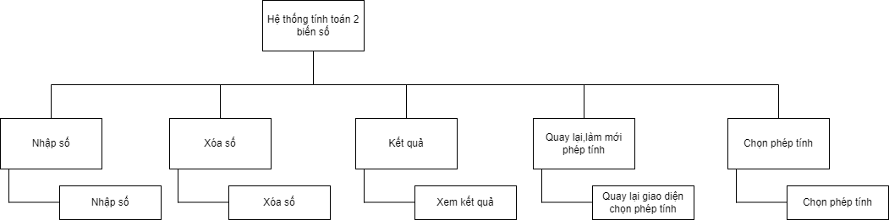

## System Context Diagram

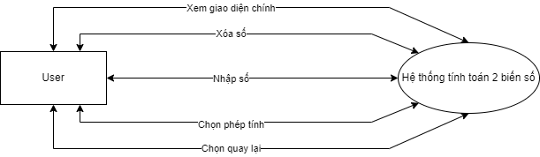

### 

## Stakeholders

| **Stakeholder** | **Description** |
| --- | --- |
| Users | System users |

## Use case diagram

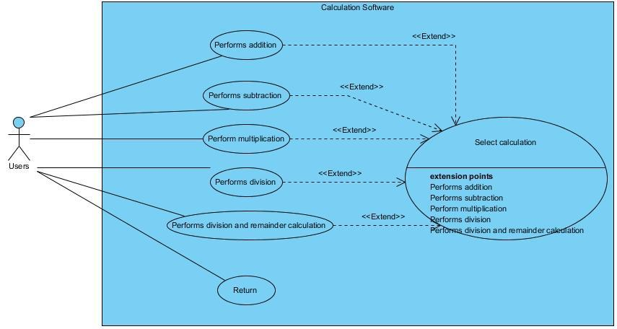

## List of use case

| **Use case ID** | **Use case name** |
| --- | --- |
| UC.01 | Select calculation |
| UC.02 | Performs addition |
| UC.03 | Performs subtraction |
| UC.04 | Perform multiplication |
| UC.05 | Performs division |
| UC.06 | Performs division and remainder calculation |
| UC.07 | Return |

## Use Case Specification

### UC 01: Select calculation.

| UseCase name: Select calculation. | |
| --- | --- |
| Brief description: The system displays the main interface allowing users to select calculations | |
| Main actor: User. | |
| Supporting Actor: None. | |
| **Prerequisites:** The system allows users to view and select the calculation interface | |
| **Post-prerequisites:** Do not have | |
| **Main line of events:** | |
| Actor | System |
| 1. Users access the system. | 2. The system displays the calculation selection interface |
| 3. Users select calculation. | 4. The system displays the required calculation interface. |

### 

### 

### 

### 

### 

### 

### 

### 

### 

### UC.02: Performs addition.

| UseCase name: Performs addition. | |
| --- | --- |
| Brief description: The system allows users to perform addition with 2 variables. | |
| Main actor: User. | |
| Supporting Actor: None. | |
| **Prerequisites:**The system must calculate and give accurate results. | |
| **Post-prerequisites:**The user must enter two correct variables. | |
| **Main line of events:** | |
| Actor | System |
| 1.Users select the "+" character in the main interface. | 2.The system displays the addition calculation interface. |
| 3.User enters 2 variables. |  |
| 4.Users select “Calculator”. | 5.Variable checking and calculation system. |
|  | 6.The system displays the results. |
| **Substream of events:** | |
|  | 5.1.Error reporting system. |
| 5.1.2.User selects confirmation. | 5.1.3.The system returns to step 2. |

### 

### 

### UC.03: Performs subtraction.

| UseCase name: Performs subtraction. | |
| --- | --- |
| Brief description: The system allows users to perform subtraction with 2 variables. | |
| Main actor: User. | |
| Supporting Actor: None. | |
| **Prerequisites:**The system must calculate and give accurate results. | |
| **Post-prerequisites:**The user must enter two correct variables. | |
| **Main line of events:** | |
| Actor | System |
| 1.User selects the character “-” in the main interface. | 2.The system displays the 2-variable signal interface. |
| 3.User enters 2 variables. |  |
| 4.Users select “Calculator”. | 5.Variable checking and calculation system. |
|  | 6.The system displays the results. |
| **Substream of events:** | |
|  | 5.1.Error reporting system. |
| 5.1.2.User selects confirmation. | 5.1.3.The system returns to step 2. |

##### 

##### 

### UC.04: Performs multiplication.

### 

| UseCase name: Perform multiplication. | |
| --- | --- |
| Brief description: The system allows users to calculate the product of 2 variables. | |
| Main actor: User. | |
| Supporting Actor: None. | |
| **Prerequisites:**The system must calculate and give accurate results. | |
| **Post-prerequisites:**The user must enter two correct variables. | |
| **Main line of events:** | |
| Actor | System |
| 1.User selects the character “x” in the main interface. | 2.The system displays the multiplication calculation interface. |
| 3.User enters 2 variables. |  |
| 4.Users select “Calculator”. | 5.Variable checking and calculation system. |
|  | 6.The system displays the results. |
| **Substream of events:** | |
|  | 5.1.Error reporting system. |
| 5.1.2.User selects confirmation. | 5.1.3.The system returns to step 2. |

##### 

### UC.05: Performs division.

| UseCase name: Performs division. | |
| --- | --- |
| Brief description: The system allows users to perform division of 2 variables. | |
| Main actor: User. | |
| Supporting Actor: None. | |
| **Prerequisites:**The system must calculate and give accurate results. | |
| **Post-prerequisites:**The user must enter two correct variables. | |
| **Main line of events:** | |
| Actor | System |
| 1.User selects the character “/” in the main interface. | 2.The system displays the division calculation interface. |
| 3.User enters 2 variables. |  |
| 4.Users select “Calculator”. | 5.Variable checking and calculation system. |
|  | 6.The system displays the results. |
| **Substream of events:** | |
|  | 5.1.Error reporting system. |
| 5.1.2.User selects confirmation. | 5.1.3.The system returns to step 2. |

##### 

### 

### 

### 

### 

### 

### 

### 

### 

### 

### 

### 

### UC.06: Performs division and remainder calculation.

| UseCase name: Performs division and remainder calculation | |
| --- | --- |
| Brief description: The system allows users to view the remainder of division. | |
| Main actor: User. | |
| Supporting Actor: None. | |
| **Prerequisites:**The system must calculate and give accurate results. | |
| **Post-prerequisites:**The user must enter two correct variables, the system must complete the division calculation first. | |
| **Main line of events:** | |
| Actor | System |
| 1.Users select the character “%” in the main interface. | 2. The system displays the interface for calculating division and remainder. |
| 3.User enters 2 variables. |  |
| 4.Users select “Calculator”. | 5.Variable checking and calculation system. |
|  | 6.The system displays results and balances. |
| **Substream of events:** | |
|  | 5.1.Error reporting system. |
| 5.1.2.User selects confirmation. | 5.1.3.The system returns to step 2. |

### UC.07: Return.

| UseCase name: Return. | |
| --- | --- |
| Brief description: The system allows users to return to the main interface to select calculations. | |
| Main actor: User. | |
| Supporting Actor: None. | |
| **Prerequisites:**The system allows users to return to the main interface to select calculations. | |
| **Post-prerequisites:**The user must be in the calculation interface. | |
| **Main line of events:** | |
| Actor | System |
| 1.User selects “return”. | 2.The system displays the return confirmation interface. |
| 3.User selects “confirm” | 4.The system displays the main interface. |

## vii. Activity Diagrams

**Select calculation.**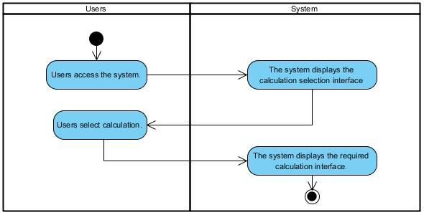

**Performs addition.**

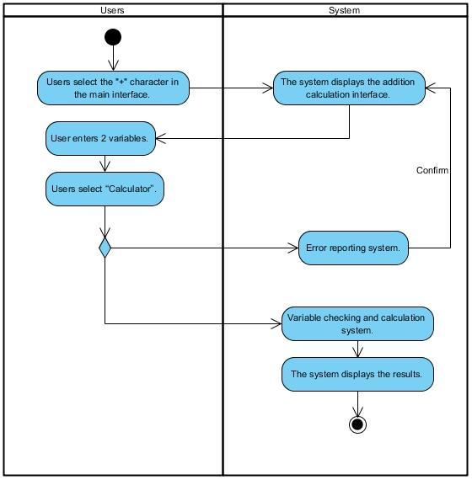

**Performs subtraction.**

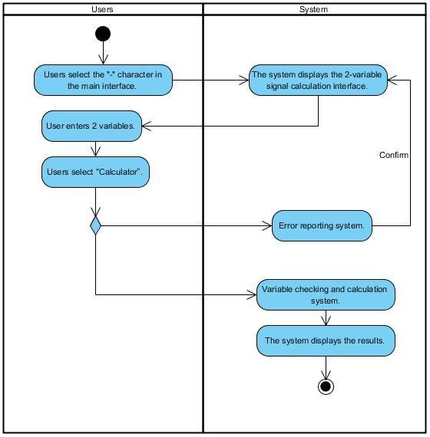

**Performs multiplication.**

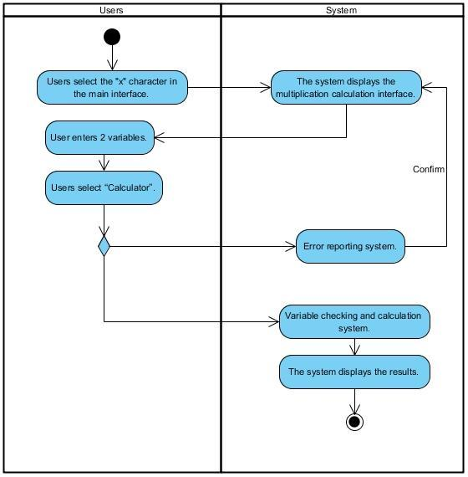

**Performs division.**

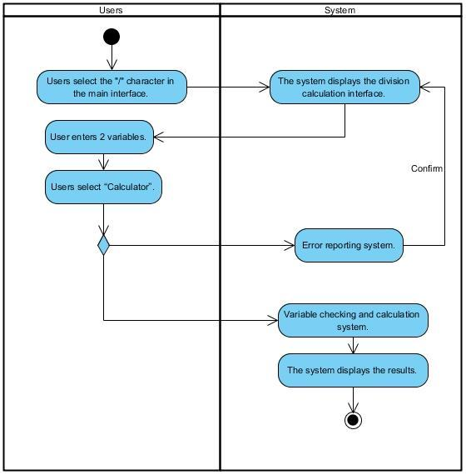

**Performs division and remainder calculation.**

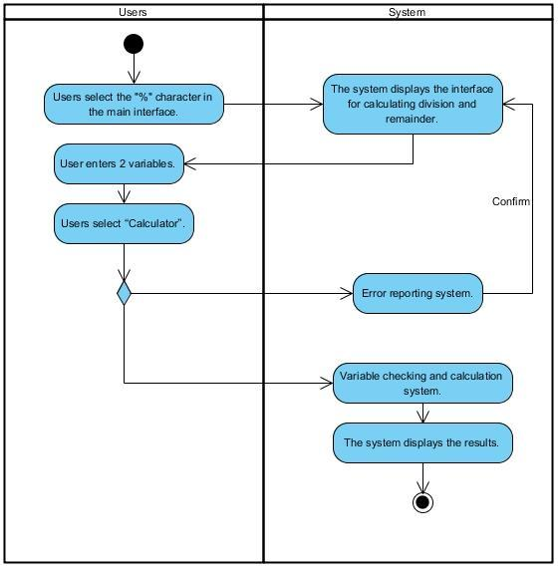

**Return.**

# 